Shivraj Pabson Cluster Examination
First Term Exam 2081
Time: 2hrs Sub:- Maths F:M=50
Class:- 8 Set "B" P:M=20
Attempt all questions.
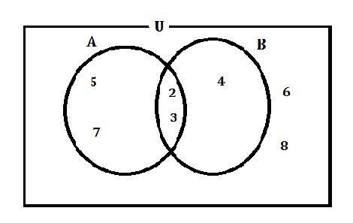
1. A venn diagram is given .

a) Define imporper sub -set . 1
b) Write all the subset with two members of set A. 1
c) Sets A and B are overlapping sets ? Justify it . 1
2. Two sub-sets of the universal set U={a,b,c,d,e} are P= {a,b,c} and Q = {c,d,e}.
a) Define overlapping set. 1
b) Write common sub-sets of the sets P and Q. 1
c) Which element of set P and set Q is to be removed to make them disjoint sets?1
3. A={x:2$≤x3, ≤4,x∈N$} B= {x:x $≤3,x∈N$ } are the sub-sets of the universal set U= {x:x$≤6,x∈N$} .
a) Write the sets A,B and U in listing method. 1
b) Write the all common sub-set of set A and B with two elements . 1
c) Write the improper subset of the set B. 1
4. a) Write the number 23500000 in scientific notation . 1
b) Convert 0.$\overline{24}$ into fraction. 2
c) Convert 435 into binary number system. 2
5. a) Convert 1.525x${10}^{4}$ into decimal number . 1
b) If 5 pens can be bought for rs.80 find how many pens can be bought for Rs 128. 2
c) Convert ${(101101)}_{2}$ into decimal number. 2
6. a) Find the ratio of 750gm and 2kg . 1
b) Simplify and write the answer in scientific notation. 3
$\frac{1.1×{10}^{3}+2.3×{10}^{3}}{1.7×{10}^{-6}}$
c) Convert 512 into quinary number system . 2
7. a) Convert 0.00000235 into scientific notation . 1
b) If 3,x,6 and 8 are in proportion find the value of x. 2
c) Convert the quinary number ${(3421)}_{5}$into decimal number. 2
8.a) if the cost of 10kg of apples is Rs .2500, what is the cost of 15kg of apples at the same rate ? 2
b) Rajan divides Rs.800 between his son and daughter in the ratio of 3:2 , find how much would each of them get ? 2
9.a) How many digits are there in binary number system and what are they ? 1
b) Which of the following numbers are irrational number ? 1
$\sqrt{4},$ $\sqrt{2},$ 0.15, $\frac{22}{7}$
c) The ratio of milk and sugar in a sweet is 5:4 . if the milk is 650gm, then find the quantity of sugar . 2
10. a) If 5,x and 20 are in continued proportion , find the positive value of x . 2
b) Simplify and write down the result in scientific notation. 2
$\frac{\left(8.6×{10}^{-3}\right)×(3.9×{10}^{-6})}{\left(3.6×{10}^{-7}\right)×(4.3×{10}^{-3})}$

11.The cost price of a mobile is Rs. 20,000 and the marked price is 20% above the cost price.
a) Write the formula to find profit percent. 1
b) Find the marked price of the mobile . 2
c) If the mobile sold for Rs.23,000 find the discount amount . 1
12) A watch with marked price Rs.15000 is sold for Rs.12000.
a) Find the discount amount . 1
b) Write the formula to find the discount percent . 1
c) Find the discount percent . 2

The End

